TASK 5 – SAME SCREEN, DIFFERENT EVENT-HANDLINGSTYLESBloom’s Level: K5 – Evaluate
7 Marks
A simple currency-converter window has an amount field, a From/To currency selection, a Convert button and a result label.

Task 5.1 – Four Implementations | 3 Marks
Implement the Convert action in four ways: (a) the frame itself implements ActionListener, (b) a named inner class, (c) an anonymous inner class, (d) a lambda expression. Alsohandle window closing using a WindowAdapter.
Task 5.2 – Change the Requirement | 2 Marks
The converter must now also convert when the user presses Enter in the amount fieldand must show the result in a dialog box. Modify each version and record howmuchcode had to change in each.
Task 5.3 – Compare the Styles | 2 Marks
Compare the four styles on readability, access to the frame’s fields, reuse of the handler and ease of change. State which style you would use for a large application and why.
Complete the Code
Complete TODO 1 and TODO 2 below. This is the lambda version (style d). Executeit and attach screenshots of a valid conversion and an invalid amount.
import java.awt.FlowLayout;
import java.awt.event.ActionListener;
import javax.swing.JButton;
import javax.swing.JComboBox;
import javax.swing.JFrame;
import javax.swing.JLabel;
import javax.swing.JTextField;
import javax.swing.SwingUtilities;
public class Converter extends JFrame {
private final JTextField amount = new JTextField(10); private final JComboBox<String> target =
new JComboBox<>(new String[]{"USD", "EUR"});
private final JLabel result = new JLabel(" ");
private static double rate(String currency) {
return currency.equals("USD") ? 0.012 : 0.011;
}
public Converter() {
super("Currency Converter");
setLayout(new FlowLayout());
JButton convertButton = new JButton("Convert");
add(new JLabel("INR")); add(amount); add(target);
add(convertButton); add(result);
// TODO 1: Register ONE lambda listener for both the Convert button and the// Enter key in the amount field
setDefaultCloseOperation(EXIT_ON_CLOSE);
pack();
}
private void convert() {
// TODO 2: Parse the amount and show the converted value with 2 decimals, or// "Invalid amount" if parsing fails
}
public static void main(String[] args) {
SwingUtilities.invokeLater(() -> new Converter().setVisible(true));
}
}

Alternative Concept and Complexity Analysis
If the Convert action were written as a method reference (this::convert) or as one sharedAction object used by the button, a menu item and a keyboard shortcut, what wouldthesolution be? Compare the number of listener objects created (space) and the workneeded to add a new trigger, with the four styles you implemented.
Evidence Expected
Four working implementations, evidence of the change effort and a reasoned comparison.

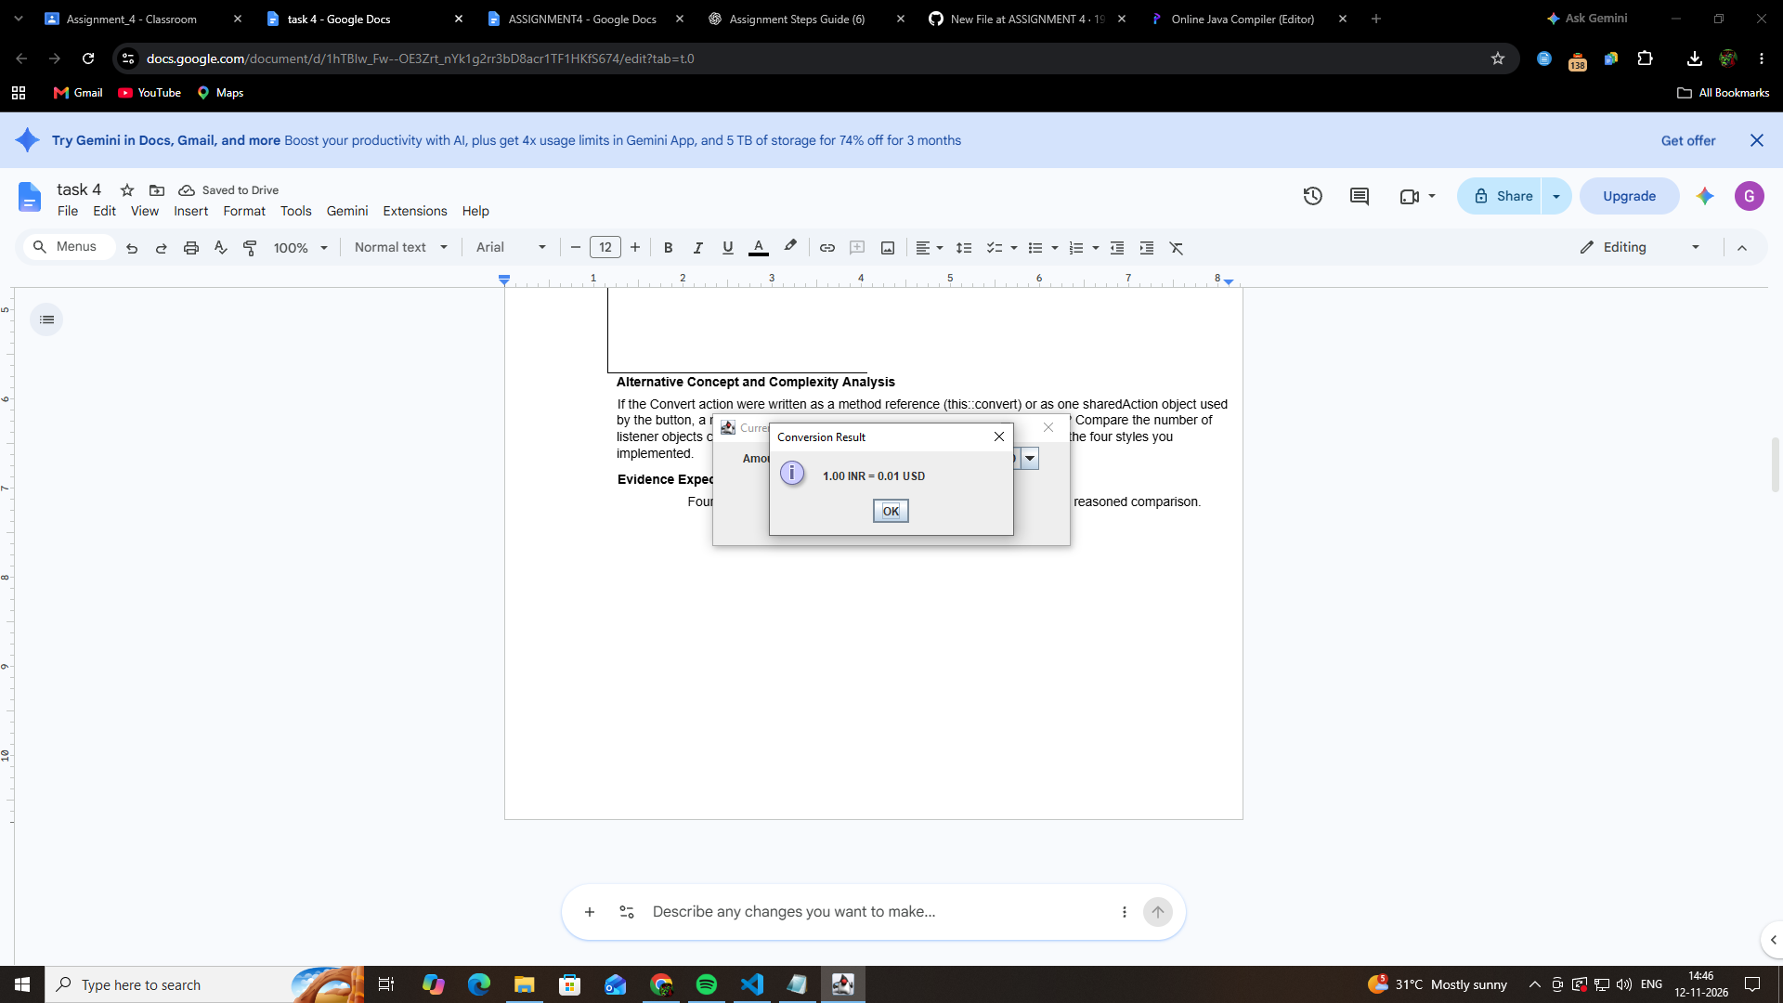

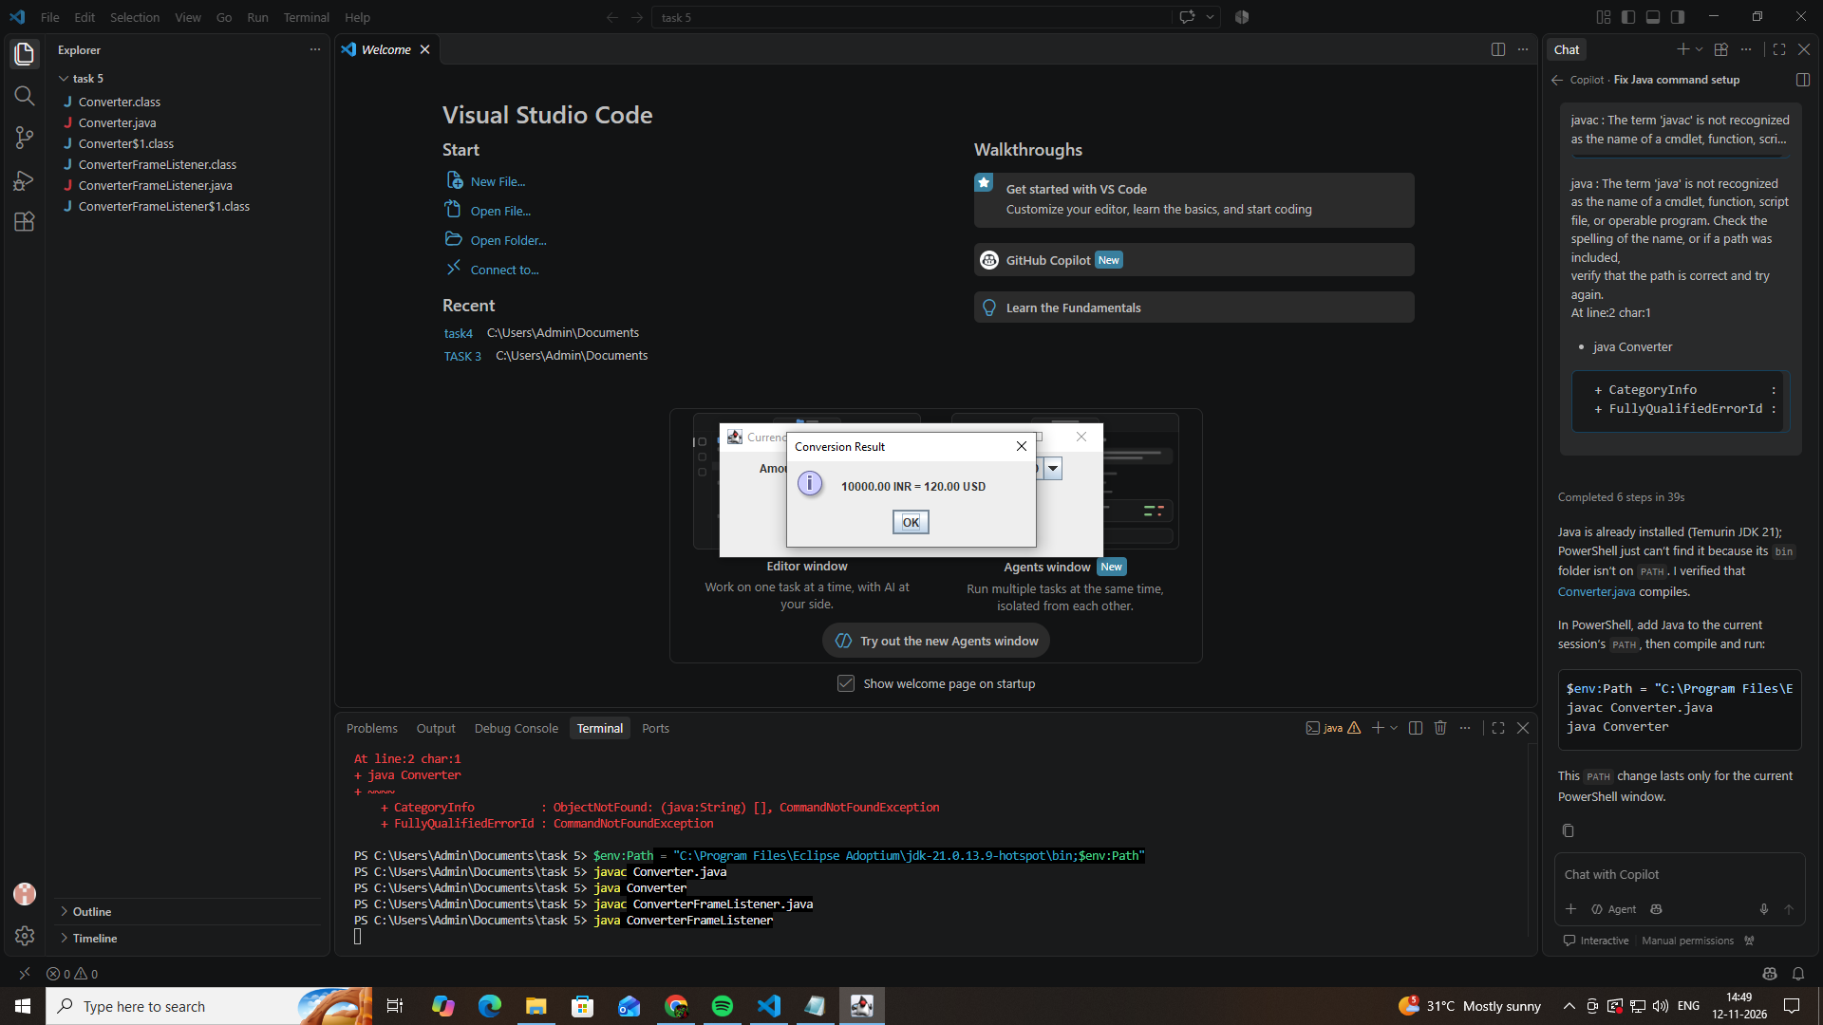

Task 5.2 – Change the Requirement (2 Marks)
Original requirement: Convert only when the user clicks the Convert button.
New requirement:
- Conversion must also happen when the user presses Enter in the amount field.
- The converted result must appear in a dialog box.

Changes made in each implementation
Style | Code changes required
A – Frame implements ActionListener | Register the amount field using amount.addActionListener(this) and add a dialog in the conversion method.
B – Named inner class | Register the amount field using the existing handler and add a dialog in the conversion method.
C – Anonymous inner class | Register the amount field using the existing anonymous handler and add a dialog in the conversion method.
D – Lambda | Register the amount field using the existing lambda listener and add a dialog in the conversion method.

Code added for Enter-key support
amount.addActionListener(handler);
For Style A, use:
amount.addActionListener(this);

Code added for the result dialog
JOptionPane.showMessageDialog(
this,
message,
"Conversion Result",
JOptionPane.INFORMATION_MESSAGE
);

Observation
All four implementations require only small changes because the same event-handling logic can be reused for both the button click and Enter-key action.

Task 5.3 – Compare the Four Styles (2 Marks)
Add this comparison table to your assignment report.
Criteria | Frame Listener | Named Inner Class | Anonymous Inner Class | Lambda
Readability | Moderate | Good | Good for short code | Very good
Access to frame fields | Direct | Direct | Direct | Direct
Handler reuse | Good | Very good | Good | Good
Ease of modification | Moderate | Very good | Moderate | Very good
Code length | Moderate | Longer | Moderate | Short

Explanation of each approach
1. Frame implements ActionListener
The main JFrame class implements the ActionListener interface. Its actionPerformed() method handles events. This approach is simple but mixes GUI components and event-handling logic in the same class.
2. Named Inner Class
A separate named inner class implements ActionListener. It provides better organization and allows the same handler object to be reused for multiple components.
3. Anonymous Inner Class
An anonymous inner class defines the event handler without creating a separately named class. It is suitable for small event-handling operations but may become difficult to maintain when the logic grows.
4. Lambda Expression
A lambda expression provides a shorter way to implement the ActionListener interface. It improves readability and is especially useful for simple event-handling operations.

